*Unit 3: Electronic Structure of the Atom*

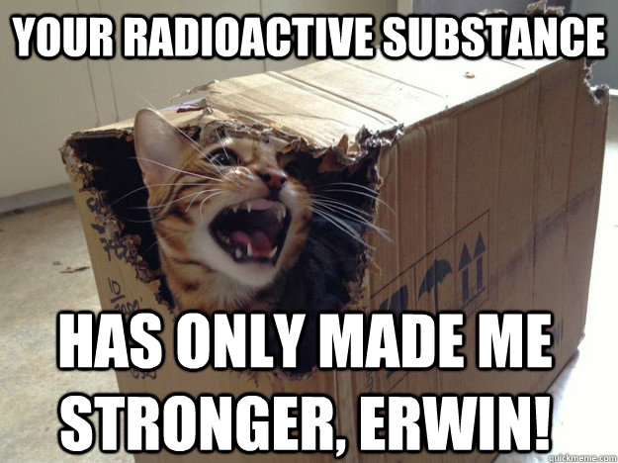

*Important Vocabulary and formulas for chapter 3*

Homework (define this)

Electromagnetic Radiation

Wavelength (λ)

Amplitude

Frequency (ν)

Quanta

Photon

Planck’s Constant

Momentum

Visible Spectrum

Absorbance Spectrum

Emission Spectrum

Photoelectric Effect

Ground State

Excited State

Orbital

Electron Configuration

Orbital Notation Diagram (Spin Diagram)

Quantum Numbers (define all four)

Aufbau Principle

Hund’s Rule

Pauli Exclusion Principle

Isoelectronic

Valence Electrons

Core Electrons

Lewis Dot Structure

c= speed of light = 2.998 × 108 m/sec

h = Planck’s constant = 6.626 × 10-34 J sec

c = λν

E = hν

E = mc2

λ = h/mc *only when particle has mass

*Notes: The Electromagnetic Spectrum and Spectra*

Refinements of the Atomic Model

## **Rutherford Model**

* A nucleus surrounded by electrons
* Did not explain how the negatively charged electrons could fill the space surrounding the positively charged nucleus
* Did not explain what prevented the negatively charged electrons from being drawn into the positively charged nucleus

# Wave-Particle Nature of Light

# Rutherford's Time

* Electrons pictured as particles
* Light pictured as waves

# Discovery in tne early 1900's

* Electrons have certain wavelike properties
* Light has certain particle-like properties

## Current Theory

## Electrons and light have a dual wave-particle nature.

## **Electromagnetic Radiation**

* Electromagnetic Radiation: - A form of energy that exhibits wavelike behavior as it travels thru space.
* Amplitude - The height of a wave, proportional to energy
* Wavelength (λ) - The distance between two corresponding points on adjacent waves
* Frequency (ν) - The number of waves that pass a given point in a specific amount of time, usually one second.
* Hertz (Hz) - SI unit of frequency; 1 wave per second; units: sec-l or s-l

Relationship between frequency and wavelength

* c = λ * ν ( c = speed of light, 3.0 x 108 *m/s )*
* Frequency and wavelength are inversely proportional

Example #1: Calculate the frequency of a photon of red light with a wavelength of 7.00 x 10-7 m.

Example #2: Calculate the wavelength of a photon of blue that has a frequency of 7.50 X 1014 Hz.

* Continuous Spectrum: - A spectrum in which all wavelengths within a given range are included
* Visible Spectrum - The portion of the electromagnetic spectrum we can see with the naked eye.
  + The visible spectrum in order of increasing energy (increasing frequency and decreasing wavelength) is: **Red, Orange, Yellow, Green, Blue, Violet**

**Light as Particles**

## Wave theory of light could not explain

* Emission of visible light by matter
* Absorption of light by matter
* Photoelectric Effect

Photoelectric Effect - The emission of electrons by certain metals when light shines on them.

* Light (as a form of energy) could knock loose an electron from the metal surfaces
* Wave theory did not explain why only light of a certain frequency of higher energy could eject the electrons

## Max Planck (1900) proposed a theory

* When a hot object releases energy it releases it in small specific amounts called *quanta*

Quantum - Finite quantity of energy that can be gained or lost by an atom.

Photon - individual quantum of light.

* Photons are thought of as particles of radiation
* Radiation is emitted and absorbed only in whole number of photons

## States of energy in atoms

* When atoms in the gaseous state are heated, they absorb the heat as potential energy and then almost immediately give off the added energy as light

Ground State: State of lowest energy of an atom

Excited State: State in which an atom has a higher potential energy than it has in its ground state

When the light given off by a particular element is passed through a prism various lines, called a line

spectrum (emission spectrum) are observed. Each colored line is produced by light of a different wavelength.

e-

E2

Elost

E1

When an excited atom with energy E2 returns to E1, it releases a photon having energy E2 -El = Elost

*Notes: The Bohr Model and Quantum Mechanical Model of the Atom*

Bohr Model of Hydrogen Atom

Neils Bohr (1913) - proposed new model of the hydrogen atom to explain the emission spectrum

* single hydrogen electron can only travel in fixed paths called orbits
* each orbit corresponds to a definite fixed energy
* when the electron absorbs energy it jumps to a higher orbit (enters "exited state")
* the electron falls back to the lower orbit (returns to "ground state") and releases light
* each line in the emission spectrum corresponds to a particular jump between orbits or energy levels

Bohr's Model did not work for atoms with more than one electron.

# Quantum Mechanical Model

Louis de Broglie (1924): proposed electrons have wave-particle nature similar to light; the electrons traveled as waves around the nucleus and could only have certain frequencies.

Erwin Schrodinger (1926): devised a mathematical equation that treated electrons as waves moving around waves. Solution to this equation is 4 "quantum numbers" that give the address of the electron in the atom.

Quantum Theory: describes mathematically the wave properties of an electron and other very small particles

Schrodinger's model:

* treats electrons as waves that have a certain probability of being found at various distances from the nucleus
* nucleus is surround by these areas of high probability called ***orbitals***

Orbitals: a three dimensional region about the nucleus in which a particular electron can be located.

* orbitals can be thought of as clouds surrounding the nucleus where there is a 90 probability of finding an electron
* the size and shape of an orbital depends on the electrons that occupy them
* the higher the energy of an electron the farther its orbital is located from the nucleus

Quantum numbers

What are quantum numbers? Quantum numbers are a set or four numbers that scientist use to identify the properties of an electron in an atom. A good analogy is to think of quantum numbers as an "address" of the electron in the atom.

Principal Quantum Number-symbolized n, indicates the main energy levels or shells surrounding a nucleus

* quantum theory equivalent of Bohr orbits
* values of n are whole numbers only (i.e. 1, 2, 3, . . .)

Orbital Quantum Number-symbolized l, indicates the shape of an orbital

* within each main energy level (beyond the first) orbitals of different shapes occupy different regions referred to as sublevels or subshells
* the first four orbital quantum numbers are designated .in ascending order (of energy) by the letters s p d f or numbers 0,1,2,3. s orbitals —1=0 —spherical

p orbitals— l = 1 —dumbbell shaped

d orbitals— l = 2 —have four lobes (one exception)

f orbitals— l = 3 —too complex

* in the nth main energy levels, n sublevels are allowed

n = 1; 1 sublevel (shapes) allowed

n = 2; 2 sublevels (shapes allowed

n = 3; 3 sublevels (shapes) allowed

n = 4; 4 sublevels (shapes) allowed

Magnetic Quantum Number-symbolized m, indicates the orientation of an orbital about the nucleus

* s orbital only has 1 possible orientation (m = 0)
* p orbital has 3 possible orientations (each along the x, y, or z axis) (m = -1, 0, or 1)
* d orbital has 5 possible orientations (m =-2,-1, 0, 1, or 2)
* f orbitals has 7 possible orientations (m = -3, -2, -1, 0, 1, 2, or 3)

Spin Quantum Number-symbolized ms, has only two possible values (+½,– ½) which indicate possible states of an electron in an orbital. By convention, the first electron is designated + ½ and the second electron is designated – ½.

|  |  |  |  |
| --- | --- | --- | --- |
| n | l | m | ms, |
| 1 | 0 | 0 | 1/2 or –1/2 |
| 2 | 0 | 0 | 1/2 or –1/2, |
| 1 | -1,0, 1 | 1/2 or -1/2 |
| 3 | 0 | 0 | 1/2 or -1/2 |
| 1 | -1,0, 1 | 1/2 or –1/2, |
| 2 | -2,-1,0, 1,2 | 1/2 or -1/2 |
| 4 | 0 | 0 | 1/2 or -1/2 |
| 1 | -1,0, 1 | 1/2, or -1/2 |
| 2 | -2,-1,0. 1,2 | 1/2 or -1/2 |
| 3 | -3,-2,-1,0, 1,2,3 | 1/2 or -1/2 |
| 5 | 0 | 0 | 1/2 or -1/2 |
| 1 | -1,0. 1 | 1/2 or -1/2 |
| 2 | -2,-1,0, 1,2 | 1/2 or -1/2 |
| 3 | -3,-2,-1, 0, 1,2, 3 | 1/2 or -1/2 |
| 6 | 0 | 0 | 1/2 or -1/2 |
| 1 | -1,0, 1 | 1/2 or -1/2 |
| 2 | -2.-1, 0, 1,2 | 1/2 or -1/2 |
| 3 | -3,-2.-1,0, 1,2,3 | 1/2 or -1/2 |
| 7 | 0 | 0 | 1/2 or -1/2 |
| 1 | -1,0, 1 | 1/2 or -1/2 |
| 2 | -2,-1,0, 1,2 | 1/2 or -1/2 |
| 3 | -3,-2,-1,0, 1,2,3 | 1/2 or -1/2 |

# Electron Configurations

Electron configuration – the arrangement of electrons in an atom

Orbital Notation Diagram - shows arrangement of electrons by using blanks for orbitals and arrows for electrons

Electron Configuration Notation - shows main energy level, sublevel, and number of electrons in that sublevel

Lewis Dot Structure - surround chemical symbol with dots representing the valence electrons

Valence electrons - electrons present in highest main energy level

Arrangement of electrons:

1. Main energy level - designated n; n can have values from 1 to infinity

2. Sublevels - contain electron clouds called orbitals

Orbitals are named from the shape of the cloud(s) it contains; can contain 2 electrons at most

* s = sphere - 1 orbital
* p = dumbell - 3 orbitals
* d = 4 lobes - 5 orbitals
* f = very complex! - 7 orbitals

For any energy level n there can be at most

* n sublevels
* n2 orbitals
* 2n2 electrons

Three rules govern electron configurations:

1. Aufbau Principle: electrons enter lowest energy orbitals first

2. Hund’s Rule: electrons enter orbitals of equal energy one at a time (Hotel rule)

3. Pauli Exclusion Principle: an orbital can hold at most 2 electrons

**ELECTRON CONFIGURATION (LEVEL ONE)**

Electrons are distributed in the electron cloud into principal energy levels (L 2,3,..,), sublevels (s, p, d, f), orbitals (s has 1, p has 3. d has 5, f has 7) and spin (two electrons allowed per orbital).

Example: Draw the electron configuration of sodium (atomic #11).

Answer:

1s2 2s2 2p6 3s1

🡩🡫 🡩🡫 🡩🡫 🡩🡫 🡩🡫 🡩 .

Draw the electron configurations of the following atoms. Include valence electrons, Lewis structure and unpaired electrons.

1. Cl

2. N

3. Al

4. O

**ELECTRON CONFIGURATION (LEVEL TWO)**

At atomic number greater than 18, the sublevels begin to fill out of order. A good approximation of the order of filling can be determined using the diagonal rule.

Draw the electron configurations of the following atoms. Include valence electrons, Lewis structure and unpaired electrons.

1. K

2. V

3. Co

4. Zr

**ELECTRON CONFIGURATIONS OF IONS**

* Atomic Number – the number of protons (or positive charges in the nucleus)
* Electrons – negatively charged subatomic particles
* Neutral Atom – an atom in which the numbers of protons and electrons are equal. There are no extra positive or negative charges
* Ion – an atom that has a positive or negative charge due to the loss or gain of electrons
* Cation – a positively charged ion formed when a neutral atom loses electrons (more protons than electrons remain)
* Anion – a negatively charged ion formed when a neutral atom gains electrons (more electrons than protons)
* Noble Gas configuration – atoms in which the outermost s and p sublevels are completely filled (outermost s only for helium); characterized as ns2np6 (1s2 for He); the MOST stable electron configurations
* Isoelectronic – two species with the same electron configuration
* Valence electrons are the electrons atoms use in making chemical bonds. Atoms form chemical bonds to become more stable. Since Noble Gases have the most stable electron configurations, atoms will gain or lose electrons to achieve the same electron configuration as a Noble Gas, or in other words, become isoelectronic with a noble gas. It is extremely rare for an atom to gain or lose more than three electrons, so the atom will either gain or lose the least number of electrons it takes to achieve the Noble Gas configuration. In general, metals lose electrons to form cations and nonmetals gain electrons to form anions.

Example: Na: 1s22s22p63s1 has one valence electron. In order for sodium to have 8, it will either have to gain 7 to become isoelectronic with Ar (1s22s22p63s23p6) or lose 1 to become isoelectronic with Ne (1s22s22p6). It is more thermodynamically favorable (easier) for sodium to lose 1 than gain 7 so sodium forms a cation with a positive 1 charge.

Na+1: 1s22s22p6

Example: S: 1s22s22p63s23p4 has 6 valence electrons. In order for sulfur to have 8, it will either have to gain 2 to become isoelectronic with Ar (1s22s22p63s23p6) or lose 4 to become isoelectronic with Ne (1s22s22p6). It is easier for sulfur to gain 2 than to lose four so sulfur forms an anion with a negative 2 charge.

S-2: 1s22s22p63s23p6

## Electron Configuration of Ions Examples

Write the complete electron configurations for each of the following ions and determine which noble gas the ion is isoeletronic with.

1. Mg+2

2. P-3

3. Al+3

4. K+1

5. F-1

6. O-2

7. Si+4

*Homework #1: Wave Theory*

***I. Answer the following questions.***

1. Define the following terms:

1. Amplitude
2. Wavelength
3. Frequency

2. What is a photon?

3. List the six colors of the visible light spectrum in order of increasing energy.

4. What is the difference between a photon of yellow light and a photon of violet light?

5. How are frequency and wavelength of an electromagnetic wave related?

***II. Solve the following problems. Show all work as directed in class or no credit will be given.***

6. An excited hydrogen atom emits light whose frequency is 1.14 x 10 14 Hz. What is the wavelength of this wave?

7. Calculate the frequency of light that has a wavelength of 2.00 x 10-7 m.

8. A certain green light has a frequency of 6.25 x 1014 Hz. What is the wavelength of this light?

9. A certain violet light has a wavelength of 4.13 x 10-7 m. What is the frequency of this light?

10. Mercury vapor lamps, used for highway and street lights, produce light corresponding to the atomic spectrum of mercury. One of the lines is green and has a wavelength of 546 nm. What is the frequency of this light? (1 m = 109 nm).

*Homework #2: Electron Configuration*

*Fill in the chart below:*

|  |  |  |  |  |
| --- | --- | --- | --- | --- |
| Element  Name | Orbital Notation Diagram | # of Valence  Electrons | Lewis Structure | # of Unpaired Electrons |
| Electron Configuration |
| Calcium |  |  |  |  |
|  |
| Arsenic |  |  |  |  |
|  |
| Cadmium |  |  |  |  |
|  |
| Cesium |  |  |  |  |
|  |
| Fluorine |  |  |  |  |
|  |
| Iron |  |  |  |  |
|  |
| Argon |  |  |  |  |
|  |
| Sulfur |  |  |  |  |
|  |
| Zinc |  |  |  |  |
|  |
| Nitrogen |  |  |  |  |
|  |
| Magnesium |  |  |  |  |
|  |
| Xenon |  |  |  |  |
|  |

|  |  |  |  |  |
| --- | --- | --- | --- | --- |
| Element  Name | Orbital Spin Diagram | # of Valence  Electrons | Lewis Structure | # of Unpaired Electrons |
| Electron Configuration |
| Lead |  |  |  |  |
|  |
| Aluminum |  |  |  |  |
|  |
| Chromium |  |  |  |  |
|  |
| Iodine |  |  |  |  |
|  |
| Mercury |  |  |  |  |
|  |
| Sodium |  |  |  |  |
|  |
| Strontium |  |  |  |  |
|  |
| Oxygen |  |  |  |  |
|  |
| Bromine |  |  |  |  |
|  |
| Potassium |  |  |  |  |
|  |
| Silicon |  |  |  |  |
|  |
| Zirconium |  |  |  |  |
|  |
| Phosphorus |  |  |  |  |
|  |
| Gold |  |  |  |  |
|  |

*Homework #3: Quantum Numbers*

Below are the orbital notations for several elements. In each case, one electron is circled. Give the four quantum numbers for the circled electron.



Example: Magnesium **n = 2 l = 1 m = 0 ms = - ½**

🡩🡫 🡩🡫 🡩🡫 🡩🡫 🡩🡫 🡩🡫

1s 2s 2p 3s

1. Silicon **n = l = m = ms =**

🡩🡫 🡩🡫 🡩🡫 🡩🡫 🡩🡫 🡩🡫 🡩🡫 🡩🡫 🡩🡫

1s 2s 2p 3s 3p

2. Lithium **n = l = m = ms =**

🡩🡫 🡩__

1s 2s

3. Iron **n = l = m = ms =**

🡩🡫 🡩🡫 🡩🡫 🡩🡫 🡩🡫 🡩🡫 🡩🡫 🡩🡫 🡩🡫 🡩🡫 🡩__ 🡩__ 🡩__ 🡩__ 🡩🡫

1s 2s 2p 3s 3p 3d 4s

4. Potassium **n = l = m = ms =**

🡩🡫 🡩🡫 🡩🡫 🡩🡫 🡩🡫 🡩🡫 🡩🡫 🡩🡫 🡩🡫 🡩🡫

1s 2s 2p 3s 3p 4s

5. Oxygen **n = l = m = ms =**

🡩🡫 🡩🡫 🡩🡫 🡩🡫 🡩🡫

1s 2s 2p

II. Below are sets of quantum numbers. Decide if each set is valid or invalid. If invalid, state what is wrong.



Identify the element for the valid sets. .

1. n l m ms

3 1 0 + ½

2. n l m ms

2 1 1 + ½

3. n l m ms

4 4 -2 - ½

4. n l m ms

3 2 -1 + ½

5. n l m ms

5 3 3 + ½

6. n l m ms

2 1 2 - ½

7. n l m ms

1 2 3 - ½

8. n l m ms

4 3 0 + ½



9. n l m ms

1 1 0 + ½

10. n l m ms

1 0 0 - ½

***HW #4 General Questions.***

1. What is the maximum number of electrons that can be identified with each of the following sets of quantum numbers. If the answer is none, explain why this is so.

a. n = 3

b. n = 2, l = 2, m = 0

c. n = 3, l = 2, m = -2

d. n = 5, l = 2

e. n = 5, l = 3, m = -3, ms = 0

f. n = 6, l = 2, m = 1, ms = + ½

2. Give the symbols of all of the elements that in their ground states have:

a. three p electrons in their outermost subshell.

b. two d electrons in their outermost subshell.

3. Complete the following statements:

a. When n = 2, the values of l can be _____ and _____.

b. When l = 1, the values of m can be _____, _____, and _____, and the subshell has the letter label _____.

c. When l = 2, this is called a _____ subshell.

d. When a subshell is labeled s, the value of l is _____ and m has the value _____.

e. When a subshell is labeled p, there are _____ orbitals within the subshell.

f. When a subshell is labeled f, there are _____ values of m and there are _____ orbitals within the subshell.

4. Write out the complete orbital notation for the following elements and write the four quantum numbers for the last electron in each case.

a. Nitrogen

b. Aluminum

c. Chromium

d. Arsenic

e. Strontium

f. Silver

g. Tin

h. Barium

i. Bromine

j. Zinc

k. Nickel

l. Sulfur

m. Silicon

n. Krypton

o. Helium

IV. Fill in the blank periodic table on the next page using the following notation for each element:

l

n m

ms

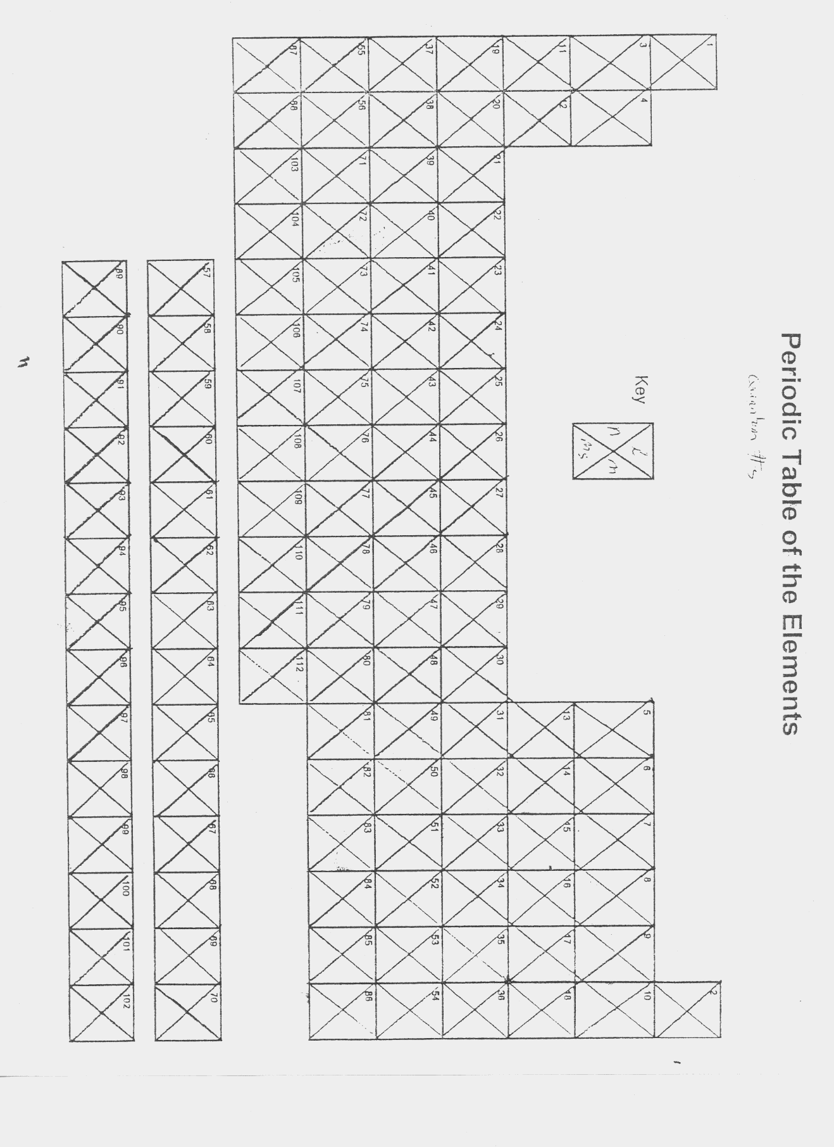

*Homework #5: Lewis Dot Structures*

**Element Lewis Dot Structure # Valence Electrons Ion Formed Electrons Gained or Lost ?**

Ex. Phosphorus P 5 P-3 Gained

1. Sodium

2. Potassium

3. Magnesium

4. Calcium

5. Chromium

6. Aluminum

7. Carbon

8. Nitrogen

9. Sulfur

10. Chlorine

*HW #6 Properties of Light Problems*

Relevant Information

c = λυ c = 3.00 x 108 m/s = speed of light

Ephoton = hυ h = 6.626 x 10-34 Js = Planck’s Constant

1. Light takes 4.37 years to reach the Solar System from the closest neighboring star, Alpha Centauri. How far away is Alpha Centauri, in meters?
2. What is the wavelength of an electromagnetic wave with a frequency of 7.65 x 1020 Hz?
3. What is the energy of a photon in the electromagnetic wave in problem (2)?
4. Purple laser pointers use the same wavelength of light as Blu-ray disc players, 405 nm. What is the energy of a photon in the purple laser pointer’s beam?
5. If the laser above (problem 4) emitted a total of 0.500 J, how many photons were emitted? How many moles of photons were emitted? ( 1 mole “anything” = 6.02 x 1023 “anything”)

*HW #7 Multiple Choice Review*

*I. Choose the best answer to each question.*

1. The spin quantum number, ms, of an electron can be thought of as describing

a. how an electron spins on an axis. b. its charge as positive or negative.

c. its exact location in orbit. d. the number of revolutions about the nucleus per second.

2. The electron configuration of aluminum is

a. 1s22s22p33s23p33d1 b. 1s22s22p63s22d1 c. 1s22s22p63s23p1 d. 1s22s22p9

3. If the third main energy level contains 15 electrons, how many more could it possible hold?

a. 0 b. 1 c. 3 d. 17

4. If electromagnetic radiation A has a lower frequency than electromagnetic radiation B, the wavelength of A is

a. longer. b. shorter

c. equal to B’s wavelength d. exactly half of B’s wavelength.

5. The main energy levels surrounding a nucleus are indicated by the

a. orbital quantum numbers, l. b. magnetic quantum numbers, m.

c. spin quantum numbers, ms. d. principal quantum numbers, n.

6. When n represents the principal quantum number of a main energy level, the number of orbitals in that energy level is

a. n b. 2n c. n2 d. 2n2

7. At n = 1, the total number of electrons that could be found is

a. 1. b. 2. c. 6. d. 18.

8. How many quantum numbers are used to describe that energy state of an electron in an atom?

a. 1. b. 2. c. 3. d. 4.

9. The number of orbitals for the d sublevel is

a. 1. b. 3. c. 5. d. 7.

10. A three-dimensional region around a nucleus in which a particular electron may be found is called a(n)

a. spectral line. b. electron path. c. orbital. d. orbit.

11. An orbital that would never exist according to the quantum description of the atom is

a. 3d. b. 8s. c. 6d. d. 3f.

12. An orbital may be defined as

1. the most stable state of an atom.
2. the circular path followed by an electron around the nucleus.

c. the positively charged central part of an atom.

d. a high probable location of an electron within the atom.

13. How many electrons do Group 18 elements (except one) have in the s and p orbitals of their outermost energy levels?

a. 1 b. 8 c. 10 d. 32

14. What values can the orbital quantum number, l, have when n = 2?

a. +½, -½ b. -½, -1, -2 c. 0 only d. 0, 1

15. The letter designations for the first four sublevels with the number of electrons available for each sublevel are

a. s:1, p:3, d:10, and f:14. b. s:1, p:3, d:5, and f:7.

c. s:2, p:6, d:10, and f:14. d. s:1, p:6, d:10, f:4.

16. How many different orbitals can exist at the third main energy level?

a. 3 b. 6 c. 9 d. 18

17. What is the electron configuration for neon?

a. 1s22s22p43s2 b. 1s21p62s2 c. 1s22s22p6 d. 1s22p63s2

18. The atomic sublevel with the next highest energy after 4p is

a. 4d b. 4f c. 5p d. 5s

19. In wave motion, the product of frequency and wavelength is equal to the

a. number of waves passing a given point in a second.

b. speed of the wave.

c. distance between successive wave crests.

d. time for one full wave to pass a given point.

20. The Lewis-dot configurations of all noble gases beginning with neon would show how many dots around the element’s symbol?

a. 1 b. 2 c. 8 d. 10

21. The element with the electron configuration 1s22s22p63s23p2 is

a. Mg b. C c. S d. Si

22. The Lewis-dot notation for an element in the third series is represented by a symbol surrounded by three dots. The electron configuration for this element is

a. 1s22s22p63s23p1. b. 1s22s22p63s13p2. c. 1s22s22p53s23p2. d. 1s22s22p63s2.

23. The Lewis-dot notation for fluorine would show

a. 9 dots around the symbol. b. 1 dot around the symbol.

c. 7 dots around the symbol. d. 8 dots around the symbol.

24 How many electrons are needed to fill the third main energy level if it already contains 8 electrons.

a. 0 b. 8 c. 10 d. 22

25. Complete the electron configuration notation for potassium: 1s22s22p63s23p6

a. 3d1 b. 4s1 c. 3p7 d. 2d1

26. Complete the electron-configuration notation for bromine: 1s22s22p6

a. 3s23p64s24p5 b. 3s23p64s24p54d10 c. 2d103s23p64s24p5 d. 3s23p64s23d104p5

27. The major difference between a 1s orbital and a 2s orbital is that

a. the 2s orbital can hold more electrons. b. the 2s orbital has a slightly different shape.

c. the 2s orbital is at a higher energy level. d. the 1s orbital can have only one electron.

28. Red light has a longer wavelength than blue light. Compared to the blue line on the hydrogen spectrum, the red line would represent

a. higher energy and lower frequency. b. higher energy and higher frequency.

c. lower energy and higher frequency. d. lower energy and lower frequency.

29. The maximum number of electrons that can occupy any single orbital at any energy level is

a. two, if they have opposite spins. b. two, if they have the same spin.

c. one. d. no more than eight.

30. The electron configuration for the element with atomic number 11 is

a. 1s22s22p63s1. b. 2s22p23p6. c. 1s22s22p43s3. d. 1s22s22p22p62d1.

31. The total number of orbitals that can exist at the second main energy level is

a. 2. b. 3. c. 4. d. 8.

32. The number of different sublevels within each energy level of an atom is equal to the value of the

a. principal quantum number, n. b. orbital quantum number, l

c. magnetic quantum number, m. d. spin quantum number, ms.

33. In the correct Lewis dot notation for sulfur, the symbol S is surrounded by

a. three pairs of dots. b. two pairs of dots and two single dots.

c. four single dots. d. two pairs of dots.

34. How many sublevels are there in the second principal energy level?

a. 1 b. 2 c. 3 d. 4

35. What shapes of orbitals are in the third principal energy level?

a. s only b. s and p only c. s, p, and d only d. s, p, d and f

36. What is the maximum number of f orbitals in one energy level?

a. 1 b. 3 c. 5 d. 7

37. What is the maximum number of p orbitals in one energy level?

a. 1 b. 3 c. 5 d. 7

38. What is the maximum number of d orbitals in one energy level?

a. 1 b. 3 c. 5 d. 7

39. What is the maximum number of electrons in the second principle energy level?

a. 2 b. 8 c. 18 d. 32

40. The formula 2n2 represents ___.

a. the number of orbitals in a sublevel

b. the maximum number of electrons that can occupy an energy level

c. the number of sublevels in any energy level.

d. None of the above.

41. Which of the following energy levels has the lowest energy?

a. 3d b. 4s c. 4p d. 4f

­­­­

42. If three electrons are available to fill three empty 2p atomic orbitals, how will the electrons be distributed in the three orbitals?

a. one electron in each orbital

b. two electrons in one orbital, one in another, none in the third

c. three in one orbital, one in the other two

d. cannot be predicted, determined by random chance

43. What is the next orbital in the series 1s, 2s, 2p, 3s, 3p?

a. 2d b. 3d c. 4s d. 4p

44. How many unpaired electrons are there in a sulfur atom?

a. 0 b. 1 c. 2 d. 3

45. What is the number of electrons in the outermost energy level of an oxygen atom?

a. 2 b. 4 c. 6 d. 8

46. How many half-filled orbitals are there in a bromine atom?

a. 1 b. 2 c. 3 d. 4

47. In order to occupy the same orbital, two electrons must have _____.

a. the same direction of spin b. low energy

c. a high quantum number d. opposite spin

48. Which of the following colors has the lowest energy?

a. green b. blue c. red d. orange

49. How many electrons can have the following four quantum numbers: (4, 3, 2, ½)?

a. 0 b. 1 c. 2 d. 4

50. The set of quantum numbers (2, 2, 0, -½) is invalid is

a. l must be n-1 or less b. m cannot equal 0

c. ms must be a whole number d. l must equal m