Unit 9: Gases

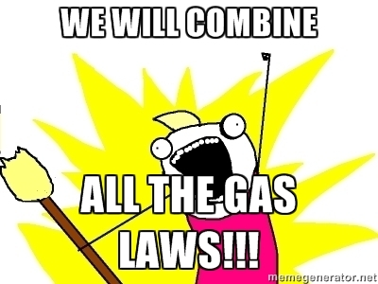

Important Vocabulary and formulas for Unit 10
Pressure
Volume
Temperature
Ideal Gas
Ideal Gas Law
Combined gas Law
Kinetic Molecular Theory (KMT)
Graham’s Law
Diffusion vs. Effusion

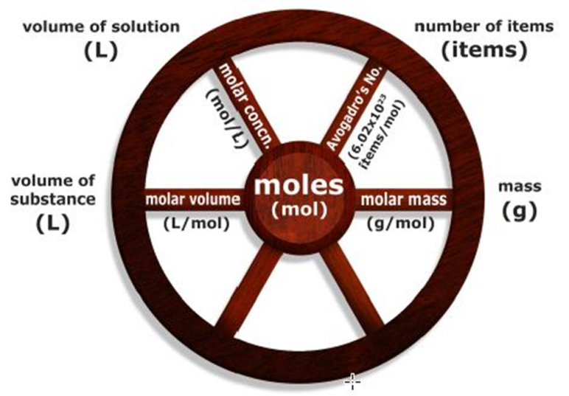
Notes: Introduction to Gases
I. States of Matter
A. Solid: state in which matter holds a definite shape and volume. The particles are closely packed together and held rigidly in place. The particles have a very strong attraction to each other (strong IMF’s intermolecular forces). Solids are considered to be a compressed state of matter (the particles cannot be pushed closer together.)
B. Liquid: state in which matter does not hold a definite shape but occupies a definite volume. The particles are still very close together, but have the freedom to change places or “flow” past each other. The particles have strong attractions to each other, but not as strong as solids. Liquids are considered to be a compressed state of matter.
C. Gas: state in which matter has no definite shape or volume. The volume of the container is the volume of the gas sample. The particles are very far apart (relatively speaking) and have little or no attraction for each other. The particles are in constant, random motion. Different gases can move through each other rapidly in a process called diffusion. Gases are matter so they do have mass. Gases exert pressure through collisions between the gas particles and their container. The pressure is dependent on the temperature of the gas. The representative particles of a gas may be atoms (He, Ne, Ra) or molecules (O₂, CO₂, CH₄, N₂, H₂). Gases are easily compressed (the particles can be pushed closer together).

II. Kinetic Molecular Theory (KMT): A simplified scientific model that explains the behavior of gases under idealized conditions.
A. Gas particles are so small compared to the distances between them that the volume of the actual gas particles themselves is assumed to be negligible (zero).
B. Gas particles are in constant motion. Collisions are perfectly elastic (think billiard balls). When particles crash into the walls of the container, they bounce off, transferring their momentum to the walls. This is what causes pressure.
C. Gas particles exert no forces on each other (no intermolecular forces). They don’t attract or repel.
D. The average kinetic energy of a group of gas particles is directly proportional to the absolute temperature of the gas sample in Kelvin.

III. Measuring Gases – In order to describe a gas sample completely and then make predictions about the behavior under changed conditions, it is important to deal with the values of four variables: amount of substance (moles), volume, temperature, and pressure.

A. Amount of substance (n) – the quantity of a given gas sample is expressed in terms of moles of gas. It can also be related to the number of particles present.

B. Volume (V) – the space occupied by matter
1. A gas will uniformly fill any container in which it is placed, therefore the volume of a sample of gas is equal to the volume of the container.
2. Memorize the following conversions: 1 L = 1 dm³ = 1000 mL = 1000 cm³

C. Temperature (T) – the average kinetic energy of the particles of a substance. The motion of gas particles increases as the temperature increases. The temperature of a gas is usually measured with a thermometer.
1. Fahrenheit (°F) – scale of temperature commonly used in the U.S. The freezing point of water is 32°F and the boiling point is 212°F.
2. Celsius (°C) – scale of temperature that is more compatible with the metric system. The freezing point of water is 0°C and the boiling point is 100°C.
3. Kelvin (K) – scale of temperature that is the SI standard. The freezing point of water is 273K and the boiling point is 373 K.
a. No degree sign (°) is used with Kelvin temperatures. There are no negative temperatures on the Kelvin scale.
c. One degree of Kelvin temperature is equal to one degree of Celsius temperature.
d. Absolute zero or 0K is the point at which particles occupy their lowest energy level.
e. All calculations involving gases should be made using the Kelvin scale.
4. Conversion between Fahrenheit and Celsius: (you do not need to memorize these)
a. °C = (°F – 32) ÷ 1.8 b. °F = (1.8 × °C) + 32
5. Conversion between Kelvin and Celsius: (you MUST memorize these)
a. °C = K – 273 b. K = °C + 273
6. Standard temperature: 0°C or 273 K (MEMORIZE this)
D. Pressure – force per unit area; the collisions of gas particles with the container walls exerts an outward push or force on the wall (if a space or volume is lacking measurable gas pressure it is called a vacuum – it is lacking matter).
1. Units of gas pressure – atmospheres (atm), mm Hg or torr, pascals, and kilopascals
2. Standard pressure: 1 atm = 760 mm Hg (torr) = 101.325 kPa (Memorize this!!!)
3. Barometers – instruments used to measure atmospheric pressure
4. Manometer – instrument used measure the pressure of a gas in a closed container; similar to a barometer; example: blood pressure cuff

E. Standard Temperature and Pressure (STP): Average pressure at sea level is 1 atm (MEMORIZE this). The Standard Temperature is 0ºC or 273 K. Memorize this too.

III. Dalton’s Law – the total pressure of a mixture of gases is the sum of the individual or partial pressures of all the gases mixed together.

A. Formula: P_{total} = P_{a} + P_{b} + P_{c} …

B. Most often applied to mixtures of water vapor with other gases when they are collected “over water”
1. P_{T} = atmospheric pressure
2. P_{T} = P_{gas} + P_{H2O}
3. P_{H2O} will be given on a table

Ex. 1) A gas is collected by bubbling it through water at a temperature of 25.0 °C. The barometric pressure is 738 mm Hg. What is the pressure of the dry gas?

Partial Pressures of water present in the atmosphere at a given temperature
°C | mm Hg | °C | mm Hg | °C | mm Hg | °C | mm Hg
0 | 4.6 | 19 | 16.5 | 26 | 25.2 | 60 | 92.5
5 | 6.5 | 20 | 17.5 | 27 | 26.7 | 70 | 233.7
10 | 9.2 | 21 | 18.7 | 28 | 28.3 | 80 | 355.1
15 | 12.8 | 22 | 19.8 | 29 | 30.0 | 90 | 525.8
16 | 13.6 | 23 | 21.1 | 30 | 31.8 | 100 | 760.0
17 | 14.5 | 24 | 22.4 | 40 | 55.3 | 105 | 906.1
18 | 15.5 | 25 | 23.8 | 50 | 92.5 | 110 | 1074.6

Notes: Individual Gas Laws and Combined Gas Law

I. Boyle’s Law: when the temperature and the number of moles of a sample of gas are held constant, its volume is inversely proportional to the pressure applied.

A. Inverse (or indirect relationship) – volume will increase with a decrease in pressure, volume will decrease with an increase in pressure.

B. Formula: P₁ × V₁ = P₂ × V₂

C. Units: Volume and Pressure may be in any units as long as you are consistent.

D. Example Problem. 50.0 mL of a a gas has a pressure of 740. mm Hg when it is in a container. What would the volume of the gas be if it was at standard pressure?

E. Boyle’s Law “over water” problems.
1. Problems involving pressure and volume changes in a gas collected by bubbling the gas through water.
2. The beginning pressure given in the problem will be the total pressure (P_{T} in Dalton’s Law).
a. First use Dalton’s Law to get the pressure of the dry gas.
b. Use the pressure of the dry gas as P₁ in Boyle’s Law.

F. Example Problem. A chemist collects 30.0 mL of a gas over water at 16°C and 581 mm Hg. What would be the volume of the dry gas at standard pressure?

II. Charle’s Law – when the pressure and amount of a gas are held constant, the volume of the gas is directly proportional to its KELVIN temperature.
A. Direct relationship – the volume will increase if the Kelvin temperature is increased; the volume will decrease if the Kelvin temperature is decreased.

B: Formula

C. Units – REMEMBER: 1 cm3 = 1 mL, 1000 mL = 1 L. Temperature must be in KELVIN.

D. Example: At 20°C, the volume of a gas is 100. mL. What would the volume of the gas be 100°C?

III. Gay – Lussac’s Law: when the volume and number of moles of a sample of gas are held constant, its pressure is directly proportional to the KELVIN temperature.
A. Direct relationship – the pressure will increase if the Kelvin temperature is increased; the pressure will decrease if the Kelvin temperature is decreased.

B. Formula:

C. Units: Pressure can be in any units (as long as you are consistent, but TEMPERATURE MUST BE IN KELVIN!!!!!

D. Example – The pressure of a tank of gas is 2.0 atm, and the temperature is 40°C. If the volume remains constant, what will the new pressure be if the temperature is lowered to 20°C?

IV. Avogadro’s Principle – if there are equal volumes of gases at equal pressures and temperatures, then each sample has an equal number of particles (moles)

A. Direct relationship – the volume will increase if the number of moles (n) is increased, the volume will decrease if the number of moles decreases.

B. Formula:

C. Units: volume can be in any units, typically we will use L or mL. “n” refers to the number of moles – it can refer to the number of particles but not grams!

D. Example – A balloon with a volume of 4.00 L is known to contain 0.200 moles of gas. How many moles of gas remain if some of the gas is released and the new volume is 3.25 L. Assume temperature and pressure remain constant.

V. The Combined Gas Law – Boyle’s, Charles’, and Gay-Lussac’s Laws and Avagadro’s combined.
A. Formula:
B. Units – any units for volume and pressure can be used as long as you are consistent, BUT YOUR TEMPERATURE MUST BE IN KELVIN!

D. Examples: Show all work including units.

1. A sample of gas has a volume of 1.25 L at 25°C and 0.876 atm. What is the new volume when the temperature decreases to 15°C and the pressure decreases to 0.750 atm?

2. A sample of gas occupies 15.0 L at 22.°C and 754 mm Hg. If the volume increases to 23.0 L and the pressure decreases to 723 mm Hg, what is the new temperature?
Notes: Ideal Gas Law

Ideal Gas Law – gives the relationship between the pressure, volume, temperature, and number of moles for a sample of gas. The Ideal Gas Law is derived from the Combined Gas Law

Assume that you have 1.00 mole of gas at STP. Then P₁ = 1.00 atm, T₁ = 273 K, n₁ = 1.00 mole, and V₁ = 22.4 L. Plugging these values into the equation above we get:

Since the standard conditions are called constants, we can create a new constant combining all of them. This constant is called the ideal gas constant and is given the symbol R.

Using the ideal gas constant, R, we can derive another gas law, the IDEAL GAS LAW which usually expressed as follows:

PV = nRT

P = pressure in atmospheres
V = volume in Liters
n = the amount of substance in moles
T = the temperature in Kelvin

Example 1: What is the pressure in atmospheres exerted by a 0.500 mole sample of nitrogen in a 10.0 L container at 22.0°C?

Example 2: How many moles of gas are present in a sample with a volume of 475 mL, a pressure of 745 mm Hg, and a temperature of 27.0°C?

Using mass or finding the molar mass: The ideal gas law uses moles. Normally we use grams in laboratory. When we are given or asked for grams instead of moles we must use the formula mass to convert between moles and grams.

Example 3: What mass of chlorine is contained in 10.0 L tank at 27.0°C and 3.50 atm?

Example 4: At 28.0°C and 725 mmHg, 750 ml of an unidentified gas has a mass of 3.90 g. What is the molar mass of the gas?

Example 5: What volume will 545 g of hydrogen gas occupy at 26.0°C and 185 kPa?

Notes: DENSITY OF GASES
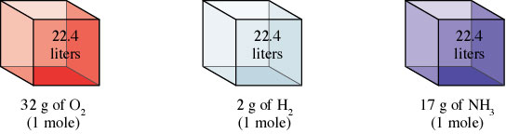
d = m = P(MM) {for ONE mole of gas} = MM AND Molar Mass = MM = dRT
V RT 22.4 L P

Just remember that densities of gases are reported in g/L NOT g/mL.

What is the approximate molar mass of air? _________

The density of air is approx. _______ g/L.
List 3 gases that float in air:
List 3 gases that sink in air:

Gas Density/Molar Mass
Example: The density of a gas was measured at 1.50 atm and 27ºC and found to be 1.95 g/L. Calculate the molar mass of the gas.

Notes: Graham’s Law of Diffusion (Effusion)

Effusion is closely related to diffusion. Diffusion is the term used to describe the mixing of gases. The rate of diffusion is the rate of the mixing.

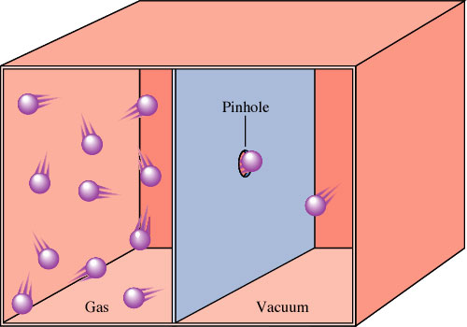
Effusion is the term used to describe the passage of a gas through a tiny orifice into an evacuated chamber as shown on the right.
The rate of effusion measures the speed at which the gas is transferred into the chamber.

The rates of effusion of two gases are inversely proportional to the square roots of their molar masses at the same temperature and pressure.
REMEMBER rate is a change in a quantity over time, NOT just the time!

Example 1: Calculate the ratio of the effusion rates of hydrogen gas (H₂) and uranium hexafluoride (UF₆), a gas used in the enrichment process to produce fuel for nuclear reactors.

13.2

Example 2: A pure sample of methane is found to effuse through a porous barrier in 1.50 minutes. Under the same conditions, an equal number of molecules of an unknown gas effuses through the barrier in 4.73 minutes. What is the molar mass of the unknown gas?

Diffusion
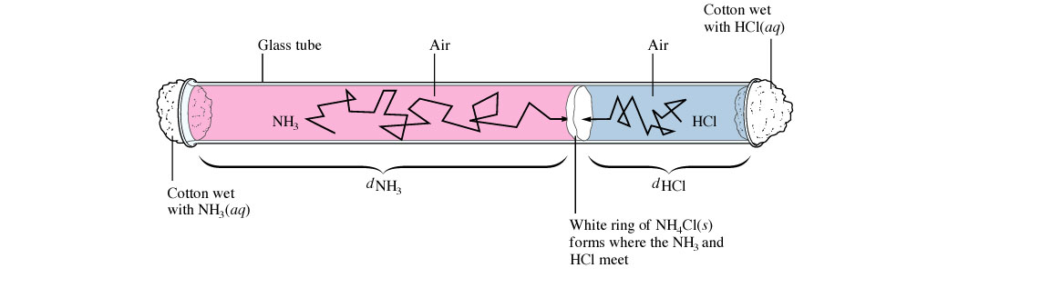
Distance traveled by NH₃ = u_{rms}for NH₃ =
Distance traveled by HCl u_{rms} for HCl

The observed ratio is LESS than a 1.5 distance ratio—why?

This diffusion is slow considering the molecular velocities are 450 and 660 meters per second—which one is which?

Notes: Gas Stoichiometry

Use PV = nRT to solve for the volume of 1 mole of gas at STP.

Look familiar? This is the molar volume of a gas at STP. Work stoichiometry problems using dimensional analysis. Use the ideal gas law to convert quantities that are NOT at STP.

Ex. 1) A sample of nitrogen gas has a volume of 1.75 L at STP. How many moles of N₂ are present?

Ex. 2) Quicklime (CaO) is produced by the thermal decomposition of calcium carbonate (CaCO₃). Calculate the volume of CO₂ at STP produced from the decomposition of 152 g CaCO₃ by the reaction

CaCO₃(s) → CaO(s) + CO₂(g)

Ex. 3) A sample of methane gas having a volume of 2.80 L at 25ºC and 1.65 atm was mixed with a sample of oxygen gas having a volume of 35.0 L at 31ºC and 1.25 atm. The mixture was then ignited to form carbon dioxide and water. Calculate the volume of CO₂ formed at a pressure of 2.50 atm and a temperature of 125ºC.

Ex. 4) Gas collection over water…use table of vapor pressures.
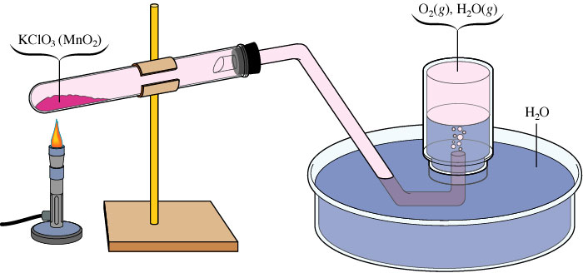
A sample of solid potassium chlorate (KClO₃) was heated in a test tube (see the figure above) and decomposed by the following reaction:

2 KClO₃(s) → 2 KCl(s) + 3 O₂(g)

The oxygen produced was collected by displacement of water at 22ºC at a total pressure of 754 torr. The volume of the gas collected was 0.650 L, and the vapor pressure of water at 22ºC is 21 torr. Calculate the partial pressure of O₂ in the gas collected and the mass of KClO₃ in the sample that was decomposed.

Notes: Ideal vs. Real Gases

Real Gases have a significant volume at high pressures.

Real Gases exhibit significant attractive forces at low temperatures.

There is no such thing as an ideal gas but helium is as close to ideal as it gets.

Sorry about the lies.
Problem Set #1

1. Using a molecular model of matter, explain what the difference is between a gas that exerts a pressure of 1.0 atm and one that exerts a pressure of 1.5 atm.

2. Using a molecular model of matter, explain why a gas can be easily compressed, while a liquid and solid cannot.

3. What are the four variables that must be used to characterize the behavior of a gas?

4. When you talk about the volume of a gas, are you referring to the volume of the molecules themselves? Explain.

5. Explain why the air pressure is greater on Waikiki Beach (on the Pacific Ocean) than it is on top of Mauna Kea, one of Hawaii’s volcanoes.

6. Carbon dioxide does not exist in the liquid state unless the pressure is at least 5.1 atm. Convert this pressure into: (Show all work WITH UNITS)
a. torr b. kPa

7. If air pressure is reduced from normal sea level values (this happens at higher elevations), the boiling point of a liquid falls. For instance, water boils at only 95°C if the atmospheric pressure is 634 mm Hg. Convert this pressure into (show all WITH UNITS):
a. atm b. Pa

8. What is a partial pressure?

9. In a flask that has a volume of 273 L, you have a sample of two noble gases, neon and xenon. The partial pressure of the neon is 96950 Pa and the partial pressure of the xenon is 1.025 atm. What is the total pressure (in kPa) exerted by these two gases?

10. What does the word kinetic imply about the molecules of a gas?

11. According to the kinetic molecular theory, what is different about a sample of xenon gas at 25°C and another sample at 100°C.

12. According to the kinetic molecular theory, what is the relationship between the average kinetic energy of a sample of gas molecules and their temperatures? What temperature scale should be used when working with gases? Why?

13. The collisions of two oxygen molecules more closely resembles which of these collisions, the collision of two sticky pieces of gum or the collision of two tennis balls?

14. Convert the following temperatures:

a. 67°C = ________ K e. 17.5°C = _________ K

b. 297 K = ________ °C f. 85 K = ________ °C

c. 0 K = ________ °F g. 66°C = ________ K

d. 0 °C = ________ °F h. 345 K = ________ °C

15. Convert the following pressures:

a. 670 Pa = ________ kPa e. 107 kPa = ________ atm

b. 54 mm Hg = ________ Pa f. 2.5 atm = ________ mm Hg

c. 2 atm = ________ Pa g. 745 mm Hg = ________ torr

d. 110 kPa = ________ torr h. 640 torr = ________atm

16. What is the pressure of dry hydrogen if it is collected over water at 25°C when the barometric pressure is 851 mm Hg?

17. What is the pressure of dry oxygen if it is collected over water at 64°F when the barometric pressure is 105 kPa?

Problem Set #2

1. The pressure of a gas is 275 mm Hg when it is confined in a 2.50 L container. What would be the volume of the gas if the pressure is increased to 800.0 mm Hg?

2. A gas has a volume of 22.4 L at 0.853 atm. What pressure is needed to change the volume to 24.0 L?

3. A gas is collected in a piston with a pressure of 2.3 atm. When the pressure changes to 3.5 atm, the volume is 325 mL. What was the original volume?

4. A gas is contained in a flask with a volume of 275 cm³. When the gas is moved to a 2.00 L cylinder, the pressure is 75.0 kPa. What was the original pressure?

5. What would be the volume of a dry gas at standard pressure if 8.23 mL of gas was collect by bubbling it through water at 27°C? The barometric pressure was 735 mm Hg.

6. A chemist collects a sample of hydrogen by bubbling it through water at 22°C. She collects 125 mL when the barometric pressure is 748 mm Hg. What would be the volume of the dry gas when the atmospheric pressure is 768 mm Hg?

7. A balloon occupies 2.o L at –45.5 °C. What would the temperature (in °C) if the balloon occupies 4.5 L?

8. What temperature (in °C) would 50.0 mL of gas be at if it occupies 74.0 mL at standard temperature?

9. A balloon is filled to a volume of 6.00 x 10² mL at a temperature of 20.0°C. The balloon is then cooled to a temperature of 1.00 x 10² K. What is the final volume of the balloon?

10. A balloon is filled helium gas at 25°C. The balloon is released and allowed to float to an altitude of 6000 feet where the temperature is 15°C. If the final volume of the balloon is 2.5 L, what was the original volume?

Problem Set #3

1. A 50.0 mL sample of gas is collected at a temperature of 15°C and a pressure of 0.987 atm, what would be the pressure of the gas if the temperature is increased to 30.0°C? Assume the volume remains constant.

2. A tank of gas has a pressure of 2.75 atm at 20°C. What will the new pressure be if its temperature is increased to 100. °C?

3. An aerosol can has an internal pressure of 3.50 atm at 20.0°C. The can will explode when the pressure reaches 12.0 atm. What will the new temperature be?

4. The pressure of an aerosol can is 2.50 atm at room temperature, 22°C. What would be the pressure in the can if it was tossed in a fire and its temperature was increased to 723 K?

5. Propane storage tanks are designed with a piston so that pressure remains constant and volume can be used to indicate the amount. When 10.0 moles of propane are placed in a tank, the volume is 250.0 L. What would be the volume (at the same temperature) if enough propane is used so that only 7.25 moles remain in the tank.

6. A balloon holds 5.00 moles of gas with a volume of 125L. If enough gas is added to expand the volume to 175 L, how many moles of gas are now in the balloon? Assume temperature and pressure are constant.

7. A 165 L sample of gas is at a pressure of 51.2 kPa and a temperature of 295 K. What volume does the same sample of gas occupy at 82°C and 1.02 atm of pressure?

8. A 250.0 mL sample of gas is at STP. What would be the pressure if the temperature was doubled and the volume was decreased by one-third?

9. A sample of gas occupies 675 mL at 23.0°C and 755 mm Hg. What would be the volume if the gas was measured at STP?

10. A sample of gas occupies 467 mL when the temperature is 35.0°C and the pressure is 115 kPa. What would be the new pressure (in mm Hg) if the volume is increased to 775 mL and the temperature is increased to 40.0 °C

Problem Set #4

1. If the gas pressure in an aerosol can is 151.6 kPa at 25°C, what is the pressure inside the can if it is heated to 300°C?

2. A 54.0 mL sample of oxygen is collected over water at 23°C and 770.0 mm Hg pressure. What is the volume of the dry gas at STP?

3. Oxygen gas is at a temperature of 40°C when it occupies a volume of 2.3 L. To what temperature (in °C) should it be raised to occupy a volume of 6.5 L?

4. Fluorine gas exerts a pressure of 900 mm Hg . When the pressure is changed to 1.50 atm, its volume is 250.0 mL. What was the original volume?

5. A sample of gas occupies 256 mL at 25°C and 720 mm Hg. At what pressure (in kPa) would it occupy 250.0 mL at 50.0°C?

6. Helium occupies a volume of 3.8 L at –45°C. What volume will it occupy at 45°C?

7. A tank for compressed gas has a maximum safe pressure limit of 825 kPa. The pressure is 215 kPa when the temperature is 24°C. What is the highest temperature (in °C) the tank can withstand safely?

8. A 3.0 L sample of gas was collected at 1.5 atm and 20.0°C. What will the volume be if the pressure is increased to 2.5 atm and the temperature is increased to 30°C?

9. A 32.0 mL sample of hydrogen is collected over water at 20.0°C and 750.0 mm Hg. What is the volume of the dry gas at STP? Careful – don’t forget to use Dalton’s Law first (there isn’t a box!)

10. A sample of carbon dioxide occupies a volume of 3.50 L at 125 kPa pressure. What pressure would the gas exert if the volume was decreased to 2.00 L?

11. A sample of argon gas is cooled and its volume went from 380.0 mL to 250.0 mL. If its final temperature was –55°C, what was the original temperature (in °C)?

12. The temperature of a gas at STP is changed to 125°C at constant volume. Calculate the final pressure of the gas in atmospheres.

13. A 4.0 L cylinder of helium has a pressure of 95 kPa. When the gas is transferred to a 6.0 L container the pressure is 101 kPa and the temperature is 198°C. What was the original temperature (in °C)?

14. A 2.0 L container of nitrogen had a pressure of 3.2 atm. What volume would be necessary to decrease the pressure to 0.50 atm?

15. A 250.0 mL sample of oxygen is collected over water at 25°C and 745 mm Hg pressure. What is the volume of the dry gas at 25°C and 760 mm Hg?

16. A 2.5 L sample of a gas has a pressure of 625 mm Hg and 22°C. What would the new temperature (in °C) be if the pressure is changed to 755 mm Hg and the volume to 1.8 L?

17. A 775 mL sample of gas is measured at 0.0°C but no one measured the pressure. Later, the gas is compressed to 500.0 mL where is has a pressure of 2.0 atm and a temperature of 25°C. What was the original volume?

18. A sample of a gas has a pressure of 655 mm Hg at 100.0°C. The same sample occupies 225 mL when the pressure is 900.0 mm Hg and the temperature is 150.0°C. What was the original volume?

19. At 850.0 mm Hg and 15°C, a sample of gas occupies 1.5 L. What would the pressure be if this same sample of gas occupied 2.5 L at 30.0°C?

Problem Set #5

1. How many moles of oxygen will occupy a volume of 2.50 L at 1.20 atm and 25.0°C?

2. What volume will 2.00 moles of nitrogen occupy at 720. mm Hg ant 20.0°C?

3. What pressure will be exerted by 25.0 g of carbon dioxide at a temperature of 27.0°C and a volume of 500. mL?

4. At what temperature (in °C) will 5.00 g of chlorine gas exert a pressure of 900. mm Hg at a volume of 750. mL?

5. How many moles of nitrogen gas will occupy a volume of 347 mL at 6680 mm Hg and 27.0°C?

6. What volume will 1.00 pound (454 g) of hydrogen occupy at 1.05 atm and 25.0°C?

7. What mass of sulfur dioxide will exert a pressure of 125 kPa at a volume of 32.5 L and a temperature of 32.0°C?

8. An element gas has a mass of 10.0 g. If the volume is 58.4 L and the pressure is 758 mm Hg at a temperature of 2.50°C, what is the gas?

9. What is the molar mass of gas if a 10.0 g sample has a volume of 0.500 L at -30.6°C and a pressure of 383.3 kPa?

10. Calculate the pressure if 1.65 g of helium gas at 16.0°C occupies a volume of 325 mL.

Problem Set #6: Gas Stoichiometry Problems

- How many molecules are in 1.23 L of carbon dioxide gas at STP?

- What volume will 25.0 g of ammonia, NH₃, occupy at STP?

- Given the following reaction, complete the questions below 2 SO₂ + O₂ → 2 SO₃

  - What volume of sulfur dioxide is required to produce 1000.0 g of sulfur trioxide? Assume that these gaseous volumes are measured at STP.

- Given the following reaction, complete the questions below H₂ + Cl₂ → HCl

  - Determine the mass of hydrogen gas needed if 4.34 L of chlorine gas is used in the reaction at STP.

- How many liters of gaseous carbon monoxide at 27°C and 0.247 atm can be produced from the burning of 65.5 g of carbon according to the following equation?
2C(s) + O₂(g) 2CO (g)

- What volume of oxygen gas in mL can be collected at 750.12 mm Hg and 25°C when 30.6 g of KClO₃ decomposes by heating, according to the following equation?

2 KClO₃(s) → 2 KCl(s) + 3O₂(g)

- What is the molar mass of a gas if 0.427 g of the gas occupies a volume of 125 mL at 20°C and 744.8 mm Hg?

- What is the density of a sample ammonia gas, NH₃, if the pressure is 0.928 atm and the temperature is 63°C?

- The density of a gas was found to be 2 g/L at 1140 mm Hg and 27°C. What is the molar mass of the gas?
Review: Gases
- At 3.25 atm and 35ºC a sample of gas occupies 755 mL. What will be the new pressure if the volume is changed to 1325 mL and the temperature to 65ºC?
  - 3.44 atm b. 2.03 atm c. 1.69 atm d. 0.997 atm

- A 125 mL sample of gas has a pressure of 548 mm Hg. If the pressure is changed to 625 mm Hg, what will be the new volume?
  - 124 mL b. 2740 mL c. 143 mL d. 110Ml

- A sample of gas has a volume of 285 mL at 25ºC. What will be the new volume of the temperature is changed to 35ºC?
  - 276 mL b. 204 mL c. 295 mL d. 399 mL

- Convert 865 mm Hg to atmospheres.
  - 0.879 atm b. 115 atm c. 8.53 atm d. 1.14 atm

- The partial pressure of water in a mixture of hydrogen and water is 450 mm Hg. If the partial pressure of hydrogen is 305 mm Hg, what is the atmospheric pressure?
a. 755 mm Hg b. 145 mm Hg c. 450 mm Hg d. 305 mm Hg

- A sample of gas is collected with a pressure of 3.25 atm at 285 K. Find the new pressure if the temperature is changed to 325 K.
  - 3.71 atm b. 2.85 atm c. 1.22 atm d. 8.67 atm

- A balloon is known to hold 0.750 moles of a gas with a volume of 15.0 L. if more gas is added so that the volume increases to 22.0 L, how many moles of gas are now present. Assume the temperature and pressure remains constant.
  - 0.511 mol b. 1.10 mol c. 440 mol d. 248 mole

- The pressure of a sample of gas at 45ºC is 1.25 atm. What will be the temperature (in ºC) of the gas if the volume is held constant and the pressure is increased to 3.65 atm?
  - 404ºC b. -90.2 ºC c. 656ºC d. -164ºC

- Convert 6.50 atm to kPa.
  - 4940 kPa b. 659 kPa c. 48.6 kPa d. 0.867 kPa

- A barometer is used to measure
  - blood pressure b. fluid levels
c. atmospheric pressure d. gas volumes

- When a gas is released from an aerosol can, the propellant expands. This causes the can to become
  - cooler b. warmer c. no change d. not enough information

- Force per unit area is the definition of
  - pressure b. volume c. temperature d. gas laws

- The air pressure in a balloon will increase when
  - the balloon is squeezed b. the temperature is decreased
c. the balloon is popped d. not enough information

- The pressure in a compressed air scuba tank is two times that of atmospheric pressure at sea level. The partial pressure of oxygen in the tank is
  - one-half that at sea level b. equal to that at sea level
c. twice that at sea level d. not enough information

- The pressure of a gas in a enclosed container is reduced to half its value when the volume is doubled. The pressure and volume must be
  - directly proportional b. inversely proportional
c. unrelated d. not enough information

- If volume and the number of moles remain constant, an increase in temperature will cause the pressure to
  - decrease b. increase
c. increase then decrease d. remain the same

- Pressure is caused by
  - the number of gas particles present.
  - the constant bombardment of molecules of a gas against the inside walls of a container.
  - the size and shape of the container.
  - the temperature of the gas particles.

- The ideal gas constant, R, is called a constant because
  - it does not change b. it cannot be measured
c. it always increases d. remain the same

- If pressure and the number of moles remain constant, an increase in volume will cause temperature to
  - decrease b. increase
c. increase then decrease d. remain the same

- 0ºC and 1 atm are called
  - the lucky temperature and pressure b. standard temperature and pressure
  - average temperature and pressure d. variables

- Atmospheres, mm Hg, and kPa are all used to express
  - volume b. temperature c. number of moles d. gas pressure

- If temperature and the number of moles remain constant, and increase in pressure will cause volume to
  - decrease b. increase
c. increase then decrease d. remain the same

- The temperature of the particles of a substance
  - does not affect the average kinetic energy of the particles in the substance
  - is directly proportional to the average kinetic energy of the particles in the substance
  - is increased when the average kinetic energy is decreased
  - is decreased when the average kinetic energy is increased

- The rate of motion of gas molecules will increase when the temperature
  - Increases b. decrease c. remains the same d. not enough information

- At constant temperature and pressure, the number of moles of gas is directly proportional to the
  - Density of gas at STP b. volume of gas
c. molar mass of gas d. rate of diffusion

- At constant temperature and number of moles, pressure and volume are
  - inversely proportional b. not related
c. directly proportional d. the same

- At constant volume and number of moles, temperature and pressure are
  - inversely proportional b. not related
c. directly proportional d. the same

- At constant pressure and number of moles, volume and temperature are
  - inversely proportional b. not related
c. directly proportional d. the same
Solve the following problems. Show all work!

- What new pressure (in mmHg) is needed to change the volume of a gas from 65.5 mL at 680 mm Hg to 0.04 L?

- What is the formula mass of a gas if 395 mL has a mass of 0.80 g at 100ºC and 800 mmHg?

- The partial pressure of carbon dioxide in a mixture of gas with water vapor at 40ºC is 725 mm Hg. What is the total pressure of the mixture?

- If a volume of gas occupies 617 mL at 40ºF, what volume (in mL) will it occupy at standard temperature?

- The pressure of a tank of gas is 2.0 atm at 40ºC. Assume volume remains constant, what will be the pressure (in atm) if the temperature is lowered to 20ºC?

- A 145 L sample of gas is at a pressure of 2.14 atm and a temperature of 156ºC. What volume does the same sample of gas occupy when the temperature is decreased to 98ºC and 659 mm Hg?
Exam Review: Gas Relationships and Stoichiometry
Answer all questions on separate sheets of paper.
- Use the balloons below to answer the following questions. All balloons are filled to the same volume of gas at STP.
F₂
Ne
Cl₂
NH₃
C₃H₈

  - Explain why the fourth balloon from the left contains the lowest mass of gas.
  - Arrange the balloons by order of increasing kinetic energy. Explain your answer.
  - All balloons are filled with gas and allowed to sit, unmolested, for 2 days. All of them have decreased in size. Which one would be the largest? Explain your answer.
  - Which gas would you expect to actually react with the rubber in the balloon? Why?
  - Which gas would you expect to deviate most from ideal behavior?
  - Which of the five gases would you expect to not react with oxygen?

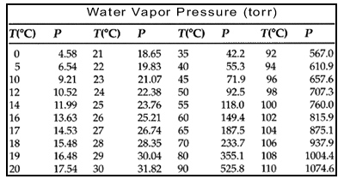
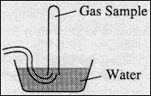
- Use the diagram and data tables below to answer the following questions.
Chlorine Gas Sample Data
Volume | 54.55 mL
Temperature | 17.0ºC
Equalized Pressure in Tube | 725 mm Hg

Little Johnny and his compadres collected some chlorine gas by displacing water in a tube.
  - Based only on the information that you are given, how many gaseous substances are in the test tube.
  - Calculate the number of moles of chlorine gas collected.
  - Calculate the number of moles of water vapor in the sample of gas.
  - Which gas would you expect to deviate most from ideal behavior? Explain your answer.
  - Calculate the mas of water molecules in the test tube.
  - Calculate the number of chlorine ATOMS in the sample.

- Ca(HSO₄)₂(s) ⇄ CaSO₄(s) + H₂O(g) + SO₃(g)
Solid calcium bisulfate, Ca(HSO₄)₂, decomposes on heating according to the equation above.

Double arrows indicate a condition known as dynamic equilibrium. The reaction proceeds in both directions as indicated by the arrows but at the same rate. When a reaction has come to equilibrium no apparent changes take place with respect to the concentrations of reactants and products. It’s important to remember that at equilibrium, both reactants and products are present.

  - A sample of 1.100 grams of solid Ca(HSO₄)₂ was placed in a previously evacuated rigid 50.0-milliliter container and heated to 200. °C. Some of the original solid remained and the total pressure in the container was 3.44 atmospheres when equilibrium was reached. Calculate the total number of moles of gas in the container.
  - Calculate the number of moles of sulfur trioxide gas.
  - How many grams of the original solid remained in the container under the conditions described in (a)?
  - How many grams of total solid can be found in the container at equilibrium?
  - How many grams of total gases can be found in the container?

- A mixture of N₂(g), Cl₂(g), and 2 milliliters of NCl₃(l) is present in 0.500-liter rigid container at 25 °C. The number of moles of N₂ and the number of moles of Cl₂ are equal. The total pressure is 1,146 millimeters of mercury. (The equilibrium vapor pressure of pure NCl₃ is 131.2 millimeters mercury.) The mixture is sparked, and N₂ and Cl₂ react until one reactant is completely consumed.

  - Write a balanced equation for this mammajamma. Don’t sass me.
  - Write an expression using Dalton’s Law to show which gases contribute to the total pressure of the container before it has reacted.
  - Calculate the partial pressures of nitrogen and chlorine gas.
  - Make a variable table. Fill it out and convert the necessaries.
  - Identify the reactant remaining after the reaction is finished and calculate the number of moles of the reactant remaining.
  - Write an expression using Dalton’s Law to show which gases contribute to the total pressure after the reaction is complete.
  - Calculate the total pressure in the container at the conclusion of the reaction if the final temperature is 58 °C. (The equilibrium vapor pressure of NCl₃ at 58 °C is 526 millimeters mercury.)
  - Calculate the number of moles of nitrogen chloride as vapor in the container at 58 °C.

- At elevated temperatures, SF₆ gas decomposes into SF₄ gas and F₂ gas, as shown by the following equation.
SF₆ ⇄ SF₄ + F₂
Double arrows indicate a condition known as dynamic equilibrium. The reaction proceeds in both directions as indicated by the arrows but at the same rate. When a reaction has come to equilibrium no apparent changes take place with respect to the concentrations of reactants and products. It’s important to remember that at equilibrium, both reactants and products are present.

  - A 10.50 gram sample of SF₆ is placed in an evacuated 5.00-liter container at standard temperature.
    - What is the concentration in moles per liter of SF₆ in the container before any decomposition occurs?
    - What is the pressure in atmospheres of SF₆ in the container before any decomposition occurs?
  - If the SF₆ is 15.5 percent decomposed when equilibrium is established at 100. °C, calculate the concentrations of each compound.
  - Draw the lewis structures for each compound. Determine the polarity of each compound.

- Three volatile binary compounds AX, BX, and CX each contain element X. The percent by mass of element X in each compound was determined. Some of the data obtained are given below.
Binary  Compound | Percent by Mass  of Element X | Molecular Mass
AX | 45.4 % | ?
BX | 93.4 % | 145.
CX | 42.0 % | 54.0

  - The vapor density of compound AX at STP was determined to be 3.53 grams per liter. Calculate the molecular mass of compound AX.
  - Determine the mass of element X contained in 1.00 mole of each of the three compounds.
  - What does volatile mean?
  - Are the binary compounds ionic or covalent? Justify your response with evidence presented in the data table or questions.
  - How many grams of compound CX are required to produce a pressure of 0.506 ATM in a 5.00 L container at 37.0 ºC?

- Diazine, N₂H₂, is a highly unstable gaseous compound. It rapidly decomposes as follows.
N₂H₂ (g) ⇄ N₂ (g) + H₂ (g)
This decomposition is exothermic. A sample of 1.218 grams of N₂H₂ is placed in an evacuated 1.00-liter bulb and the temperature is raised to 300. K.
Double arrows indicate a condition known as dynamic equilibrium. The reaction proceeds in both directions as indicated by the arrows but at the same rate. When a reaction has come to equilibrium no apparent changes take place with respect to the concentrations of reactants and products. It’s important to remember that at equilibrium, both reactants and products are present.

  - What would be the pressure in atmospheres in the bulb if no dissociation of the N₂H₂ (g) occurred?
  - When the system has come to equilibrium at 300 K, the total pressure in the bulb is found to be 1.50 atmospheres. Calculate the partial pressures of N₂, H₂ and N₂H₂ at equilibrium at 300. K.
  - How many moles of hydrogen were produced?
  - How many moles of diazine have reacted when the reaction comes to equilibrium?

- 2 NaHCOO(s) + H₂SO₄ (s) → 2 CO (g) + 2 H₂O (l) + Na₂SO₄ (aq)

A 1.000 gram sample of a mixture of sodium formate and sodium chloride is analyzed by adding sulfuric acid. The equation for the reaction for sodium formate with sulfuric acid is shown above. The carbon monoxide formed measures 242 milliliters when collected over water at 752 mm Hg and 22.0°C.

Use the above data and the water vapor pressure table from question #2 to answer the following questions.

  - What two gases contribute to the total pressure?
  - Draw a diagram to illustrate your answer in question a.
  - Calculate the mass of carbon dioxide formed.
  - Calculate the percentage of sodium formate in the original mixture.
  - How many grams of sodium sulfate could be produced when 34 grams of sodium formate react?

